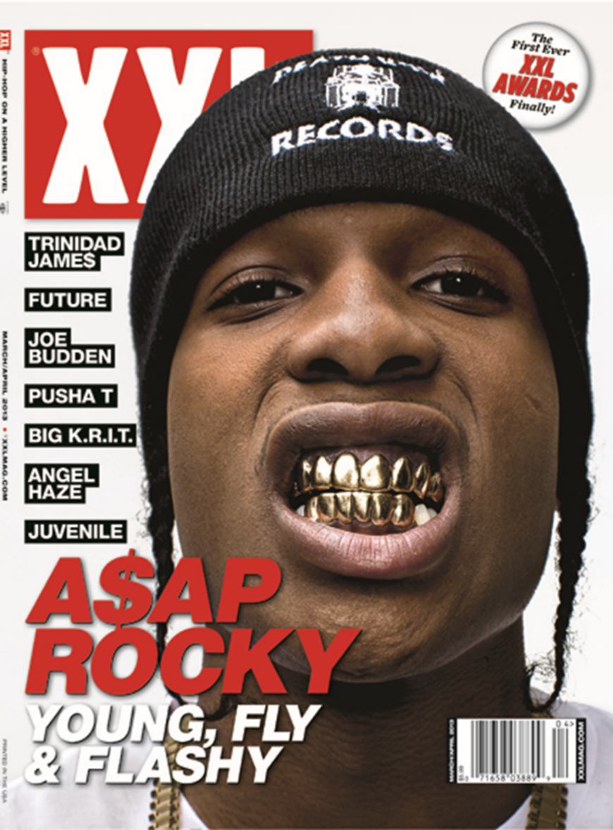

The artists image is overlapping the masthead. This technique is used when the magazine company believes their magazine is well known enough to be covered, even with it covered people will know the company. The technique makes the image more realistic and interesting to view. This is an important factor as the main image is arguably the most important aspect of a front cover.

The text used within the magazine is all sans serif. This font indicates to the reader that the magazine is not ‘formal’ or ‘sophisticated’, it is more informal and laid back. This is furthered by the coverlines which uses trendy terminology such as ‘fly’ etc.

The artist is using direct mode of address by gazing directly into the camera. This technique gives a more intimate approach and the reader feels as though the magazine is targeted towards them as the ‘eye contact’ is so personal. They are then more likely to buy the magazine as they are more attached to it.

The coverlines for this magazine are minimal. There is a list of artists we can assume are mentioned within the magazine, however it does not explain why they are mentioned. The coverline used for ‘A$AP Rocky’ is ‘Young, Fly & Flashy’. This minimalistic coverline is so unspecific and broad that the reader is unsure why he is all of this things, building integument and causing the reader to want to read on.